Software Requirement Specification

Vaccination Record iOS App

**COSC 4355 Team 6**

Lance Truong

Subash Dantuluri

Duy Ho

Chuong Le

Brian Nguyen

Table of Contents

1. INTRODUCTION

1.1 Purpose 3

1.2 Scope 3

1.3 References 3

2. Overall Description 3

2.1 Product perspective 4

2.1.1 System Interfaces 4

2.1.1 User Interfaces 5-9

2.1.3 Hardware Interfaces 9

2.1.4 Software Interfaces 10

2.2 Site Adaptation Requirements 10

2.3 User characteristics 10

2.4 Constraints 10

2.5 Assumptions and dependencies 10

3. SPECIFIC REQUIREMENTS 10

3.1 Actor 10

3.2 Use Case model 11

3.3 Story board 11

3.4 Database 12

Appendix

# Introduction

This Software requirements specification for Vaccination Record iOS App will provide the basic outlook of what software requirements at this point. Vaccination record will enable staff to access child health history in order to provide them vaccination on correct manner of time. It also enable sharing the child record within our network so that every people who related to our system all around the world can access to it. This SRS provides detailed information on the internal, external view of the system and also user interfaces.

## Purpose

This SRS is to define the requirements for developing the Vaccination Record iOS app, known as “the App” hence forth, as in accordance to the “Records for Life” contest defined in the RFP on Bill and Melinda Gates Foundation. By reading this document, you can understand how our program is developed and know exactly how it work .

This SRS is for members of team six and any other person interested in the development of the App.

## Scope

The development effort will produce an application that will run on an iOS ipad device. The App serve at least five functions in a health system:

A unique identifier that is intimately connected to the child

A source of critical information for health workers about the child’s health and vaccination status, and what the child needs at each point of contact with the health system

A source of critical information for families, such as date of next visit for vaccination

A source of critical information for household surveys, which many countries and policymakers rely on to validate coverage levels obtained from administrative data systems

An educational tool for families to learn more about health interventions

## References

RECORDS FOR LIFE CONTEST “<http://www.gatesfoundation.org/How-We-Work/General-Information/Grant-Opportunities/Records-for-Life-RFP>”

# 2 Overall Description

Vaccination Record iOS App as mentioned throughout this document will be a software product which will allow the Staff to easily access to a child profile in order to know its vaccination history and record, Then modify when needed. This program will be created in X-code using Objective C language.

**2.1 Product perspective**

This product is helpful to the Vaccination Record iOS App because it will independently allow the staff to be able to access, record and modify the child entries. This product will allow the staff to keep track of their patient’s information, records , and history of vaccination.

Ipad can only be connected to the system through cellular data service or Wi-Fi connection. The staff will interacting with a 1024x768 pixel Led multi-touch screen, on screen keyboard, 5 Mega Pixel Camera. The app is compatible with the current version iPad iOs 7.3.

Current support version of iPad: iPad2, iPad 3, the new iPad, iPad Air.

**2.1.1 System interfaces**

This section describe the main system interfaces.

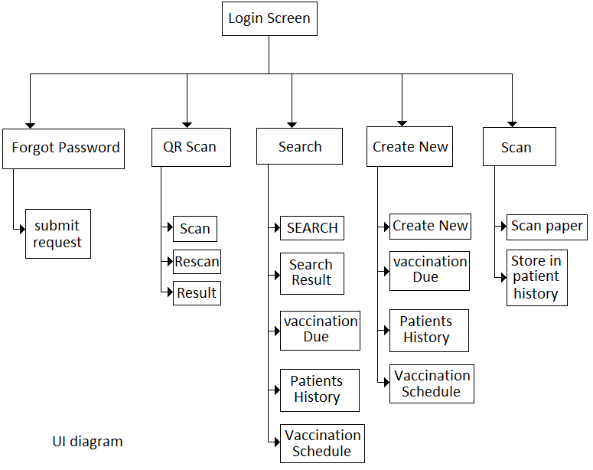

**2.1.2 User interfaces**

This will describe the way users interact with the app.

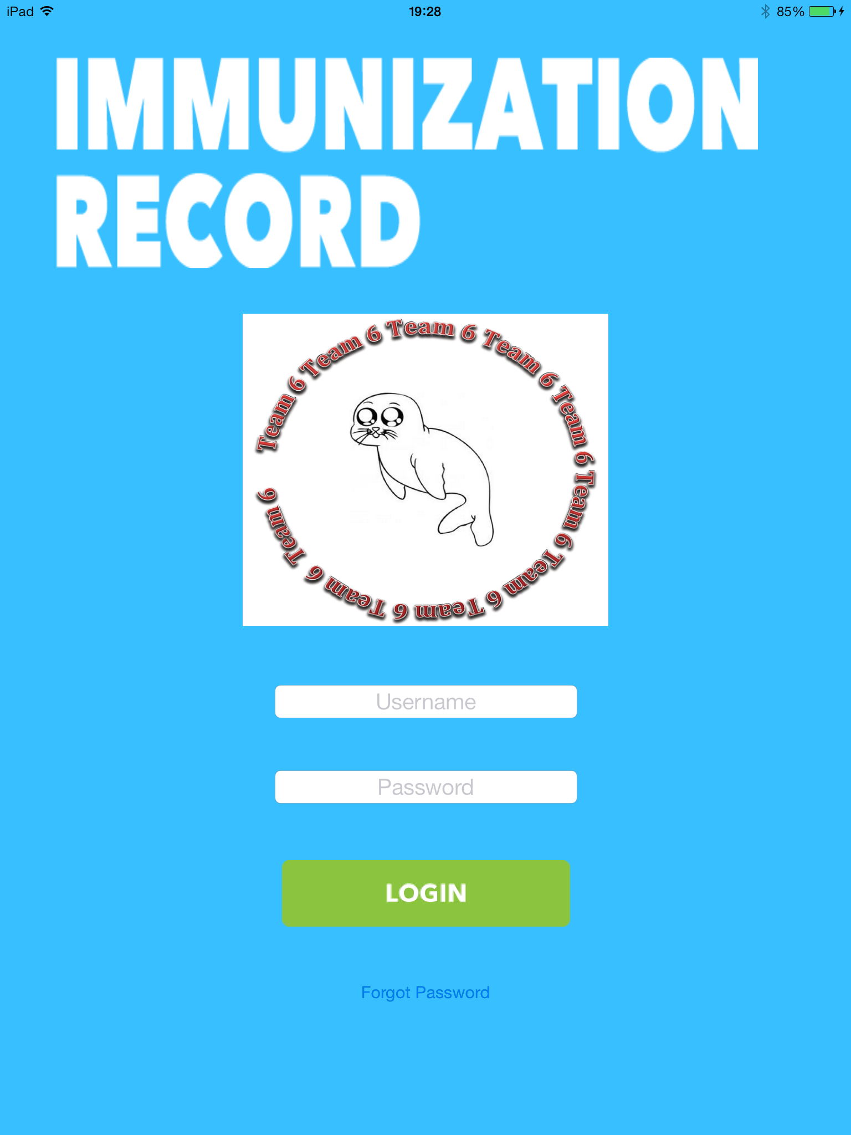

**1.Login screen menu**

When staff start the application, this is the first

screen that appear. Staff need to enter his assigned

Username and password for security. If they forget

their password , they need to contact admin site to

vertify their information before they are given new

password.

This page is to secure that only allowed staff or doctor can access to the patient database.

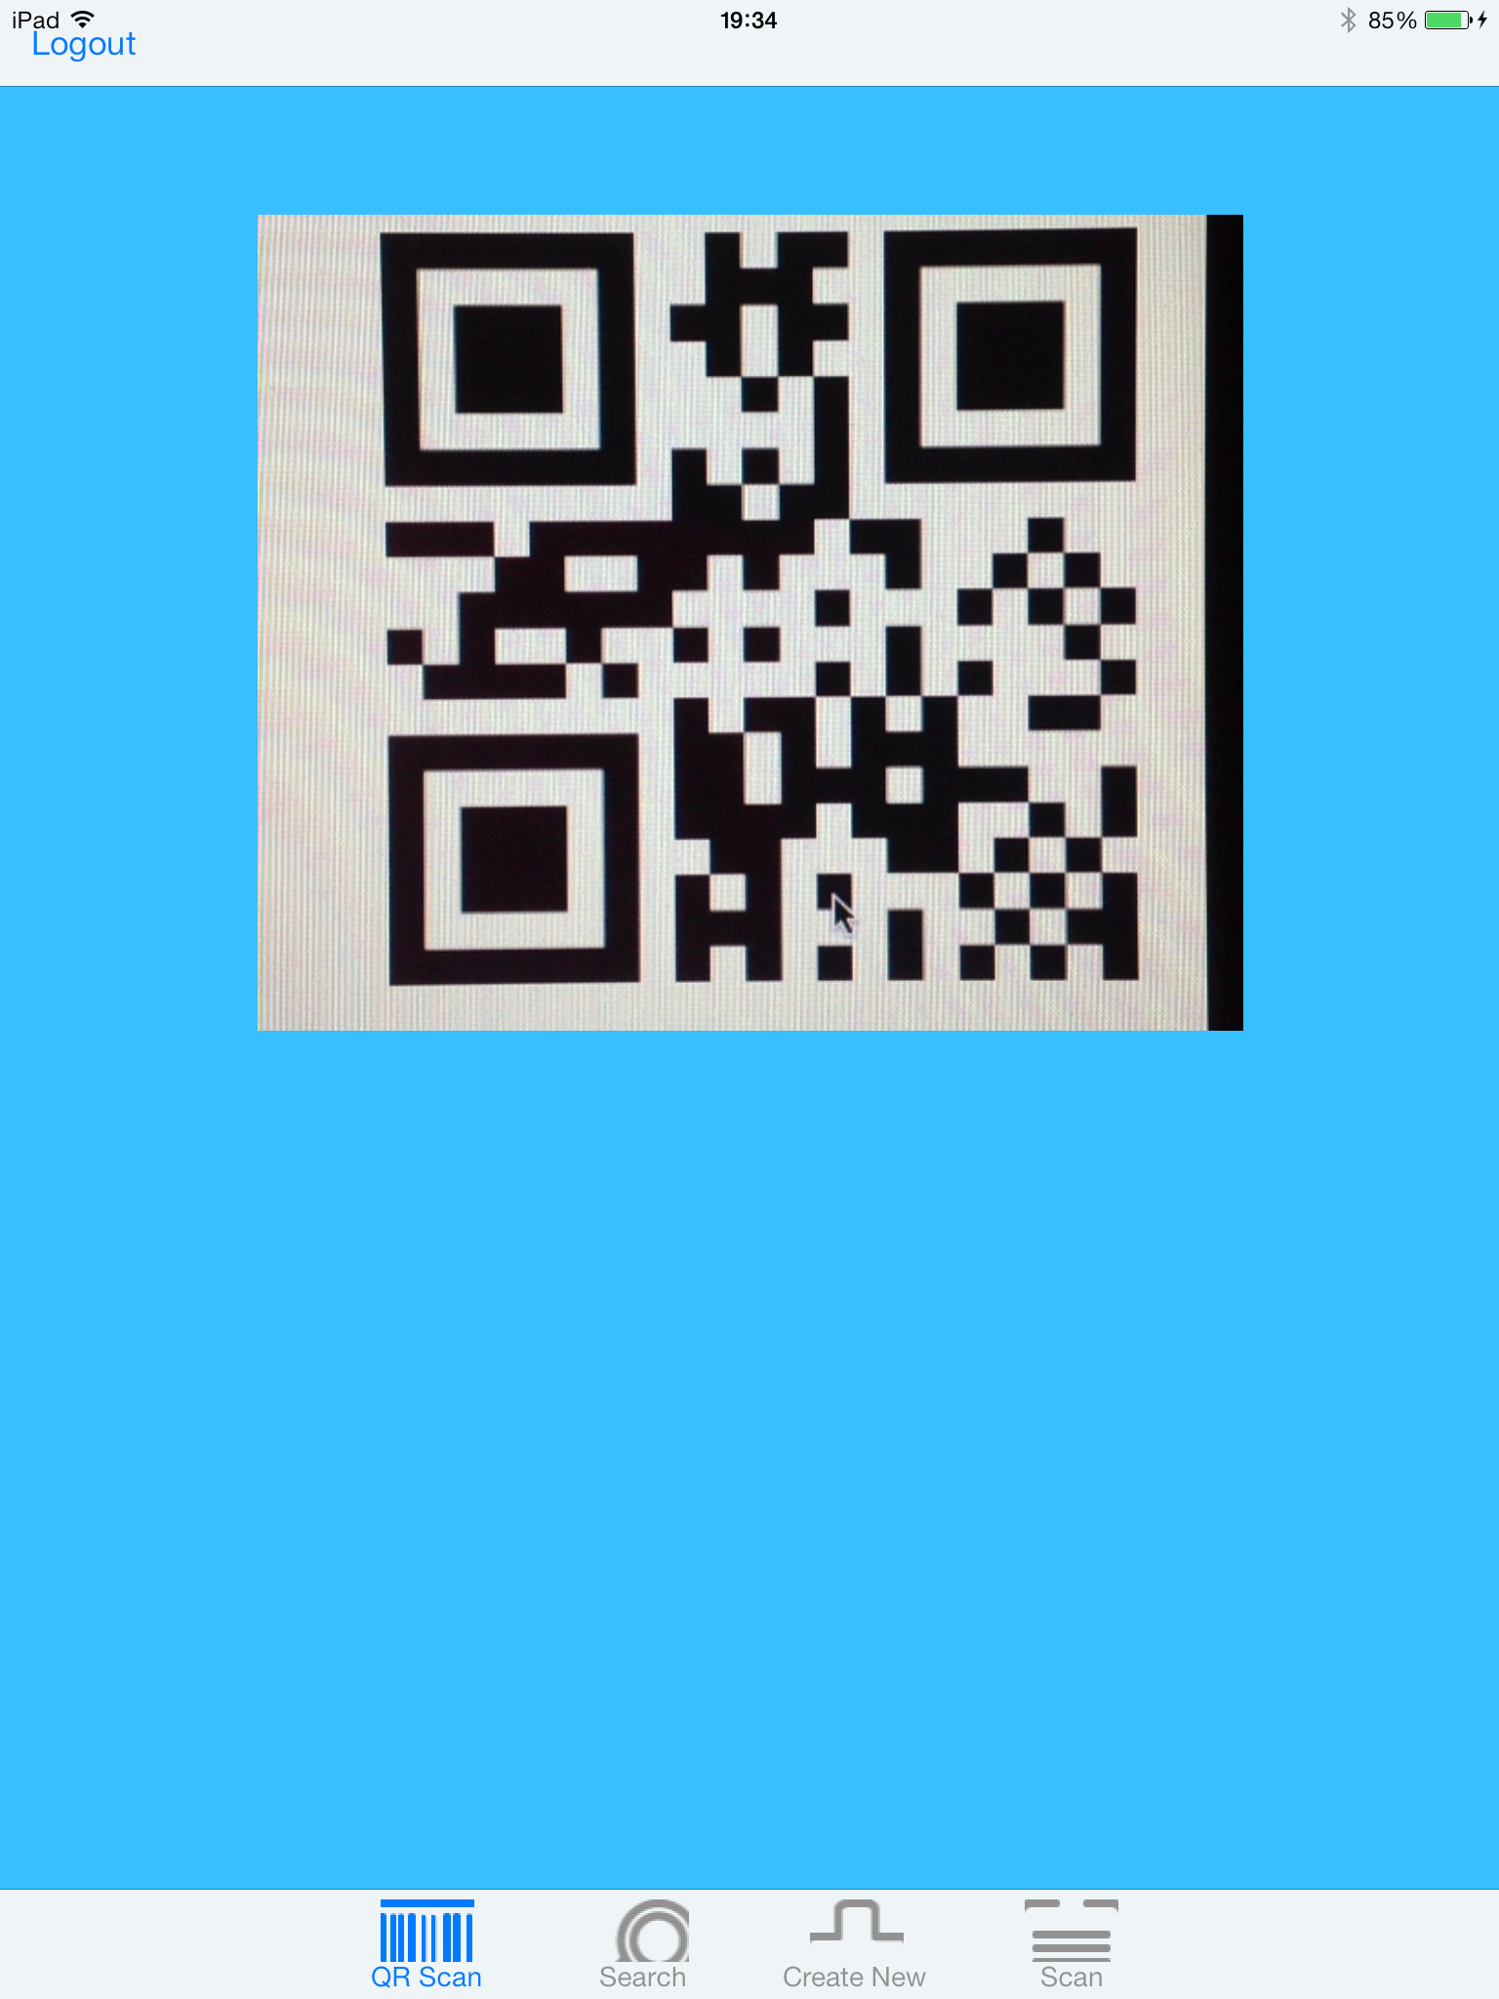

**2.QR scan menu**

After log in, then this screen will appear. It contain for 4 button in respectively: QR Scan, Search, Create new, Scan.

If the patient has the paper of vaccination record with them, for quick access to that patient information, staff can scan the QR code that appear on patient paper. System then will translate this QR code and then link to patient information (if found).

This will link to section 4 below.

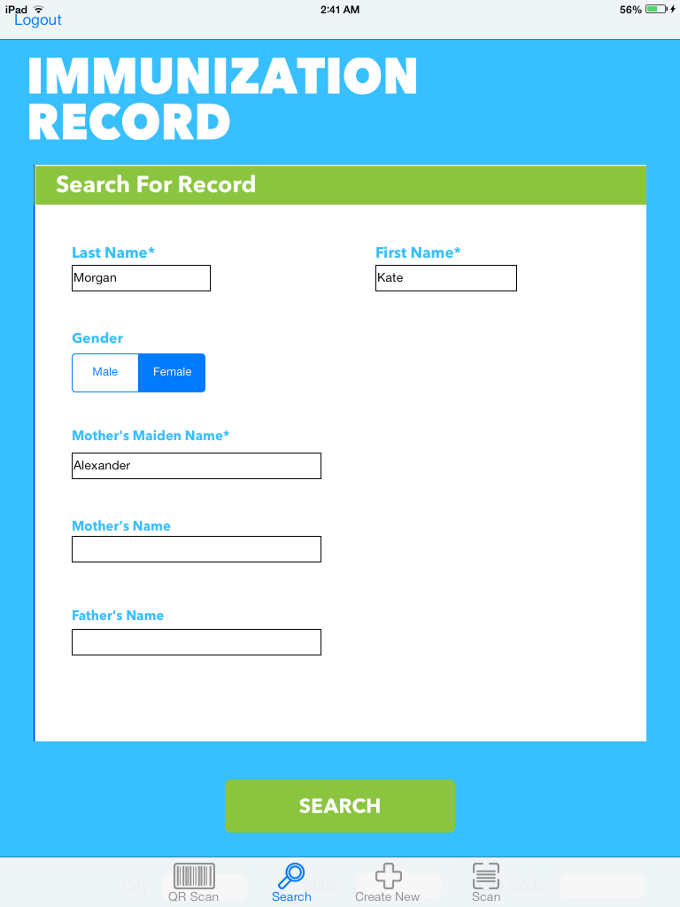

**3.Search menu**

If the patient do not bring any paper work with them, then staff should click on the search button on the menu to find the patient information. Then a “SEARCH For Record” screen will appear

In this page, staff will enter information they got from the patient : First Name, Last Name , Gender, Mother Maiden Name, Father name.. Then click search and the app will find patient information in the database. If not found , nothing will happen. If found screen will be link to that patient page.

For example, here we will find a child name kate morgan

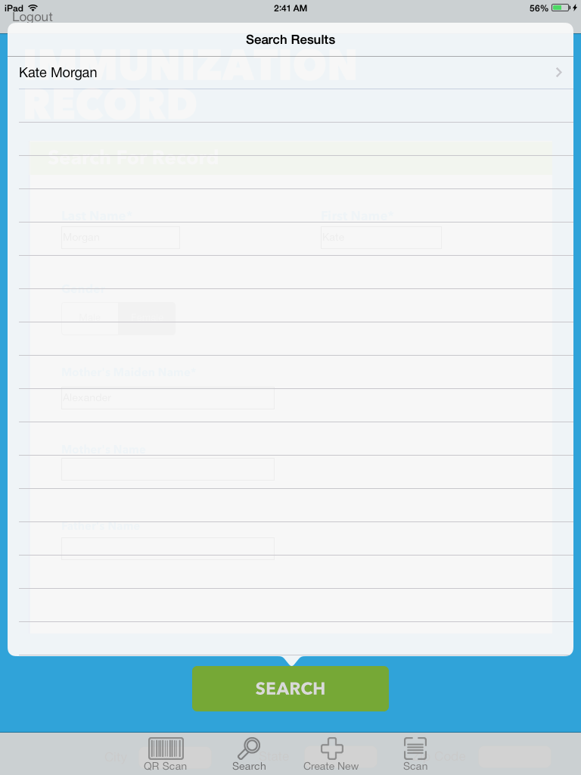

**4. Search result menu**

As mentioned in above section 3, if found Search result screen will appear. Or if found in section 2, this screen will also appear.

If app find the child with name kate morgan in the database, it will appear on the Search Results menu. Now staff just need to click on the child name to access the child‘s information

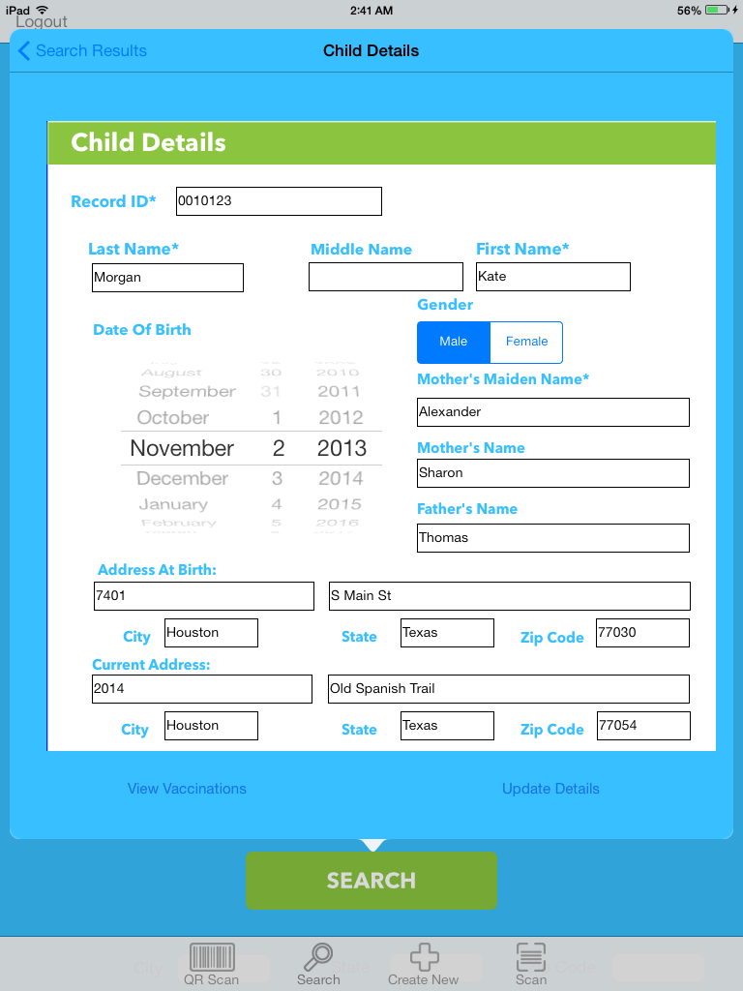

**5.Child details menu**

From “Search result menu “ , click on the child appear will link to this screen , the child information.

It will show basic information of the child like: First Name, Last Name , Date of Birth , Gender, Address At birth(City, State, Zip code), Mother Maiden Name, Current address(City, State, Zip code).

If the staff need to update new information, he/she just edit the text and then click Update details button. The new information will be saved into database.

Or if the information of the child is correct, staff can go ahead on the vaccination details by clicking on View Vaccinations.

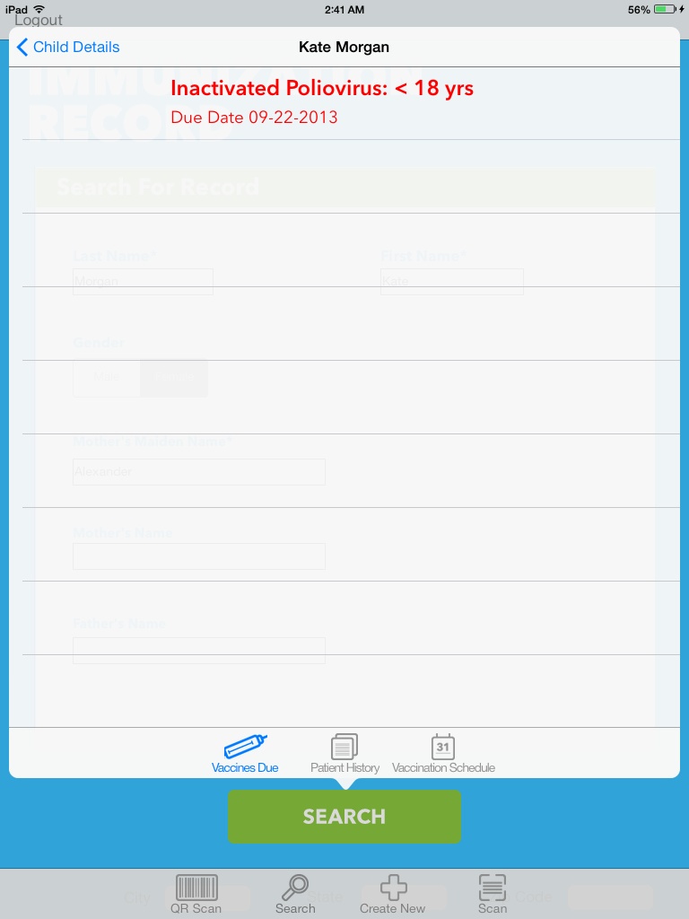

**6.Vaccine due menu**

This record is belong to the child staff is looking for. It will show which vaccine need to be taken by the child on show date according to vaccination history

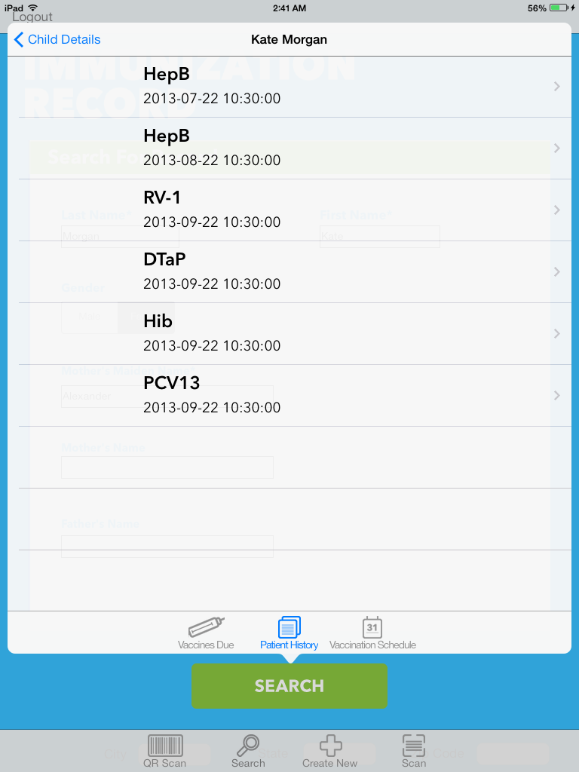

**7.PATIENT HISTORY menu**

This page will show history of vaccine taken by the child. Name of vaccine taken and date taken. Everything that was recorded will be here.

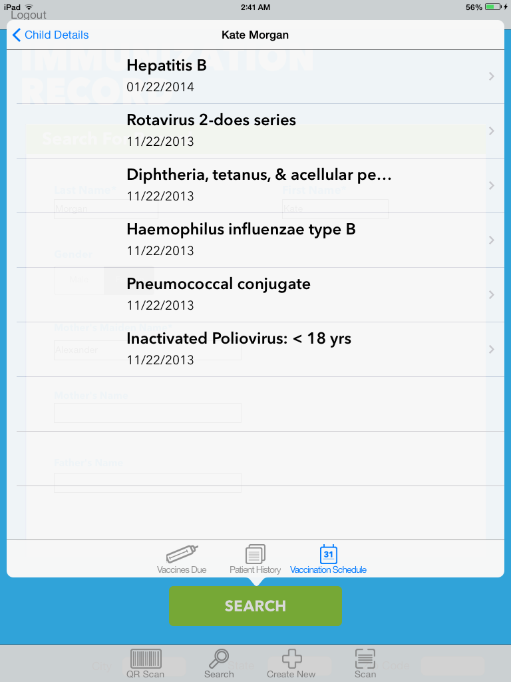

**8.VACCINATION SCHEDULE menu**

If the doctor/ staff plan to give the child an vaccination on specific date, it will appear here. Staff will click on “VACCINATION SCHEDULE” to make an appointment on which vaccine to inject on which date.

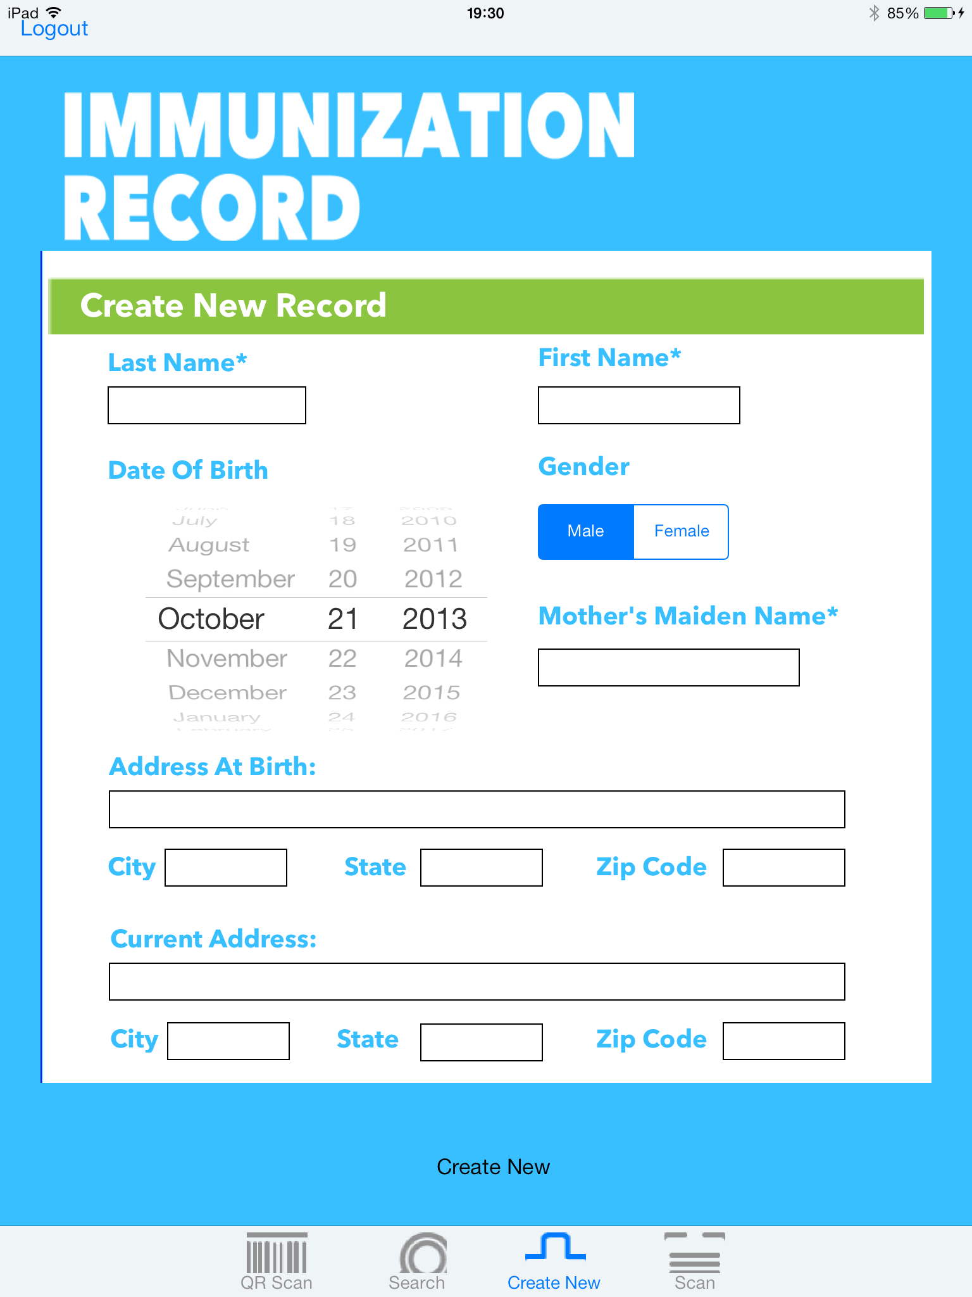**9. Create New record menu**

If the QR scan does not find the child, or search can not find the child either. That last choice to do is create new record for that child. Or if that child first time to come , Create New Record will also be used.

Staff will click on “Create new” button and this screen will appear.

Here staff/doctor will input information of the child : First Name, Last Name , Date of Birth , Gender, Address At birth(City, State, Zip code), Mother Maiden Name, Current address(City, State, Zip code).

After input all information, Staff/doctor will tap on “Create new” button. New child will be created and saved in the database. Then the screen will be linked to section 6 where staff/doctor can input new vaccination record for the child.

**2.1.3 Hardware interfaces**

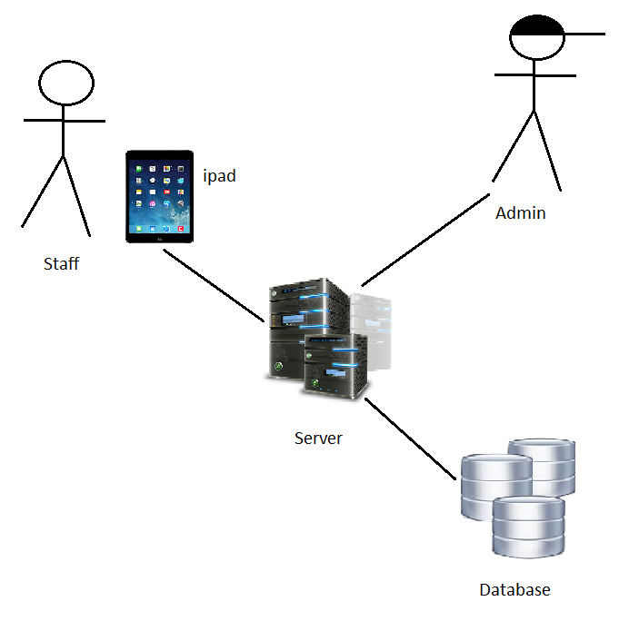

The above figure how the Vaccination iOs app System .This system can only be access from terminal and ipad. Terminals are used by operating administrator and system analysts. Staff/doctor and nurse at clinic can also access as well by using their provided username and password. Vaccination iOs app System is hosted on a 3rd party hired server provider. They will provide host and data storage for the whole system.

**2.1.4 Software interfaces**

Refer to section 2.1.1, 2.1.2, 2.1.3 about hardware and user interface

**2.2 Site adaptation requirements**

Currently the app can be only used on ipad 2,3, new ipad, ipad air. Futher device such as iphone or imac will be released in the future

**2.3 User Characteristics**

The user is assumed to be familiar with iPad to perform basic action like navigational, input ,swipe, touch assist.

**2.4 Constraints**

Vaccination Record iOS App requires live connection thoroughly using the app. If a connection is lost ,then the staff may only view current screen which has been downloaded. He can not interact with system anymore. When he click on something it will show “connection lost” and exit app.

**2.5 Assumptions and dependencies**

# We assumes that there will be a database hosted by a server. The server is provided by a well-known and trusted 3rd party to ensure that the database is online 24 hours/7days. We, the developer also assumes that the users must have an iPad with a good Wifi source/ or cellular data enabled to access internet. The app only run online. No other device than iPad is supported until further announcement.

# 3. Specific requirements

**3.1 Actor**

**Role: Patient**

Most patient is child under 18 (according to Melinda and gate requirement)

**Role: Health admin**

This can be staff/nurse/doctor or anyone that are permitted to take action on the child, access record, inject vaccination.

**Role: administrator**

Taking care of the system. These people will maintain system and support for user (health admin) in password/username recovery.

**3.2 Use Case Model**

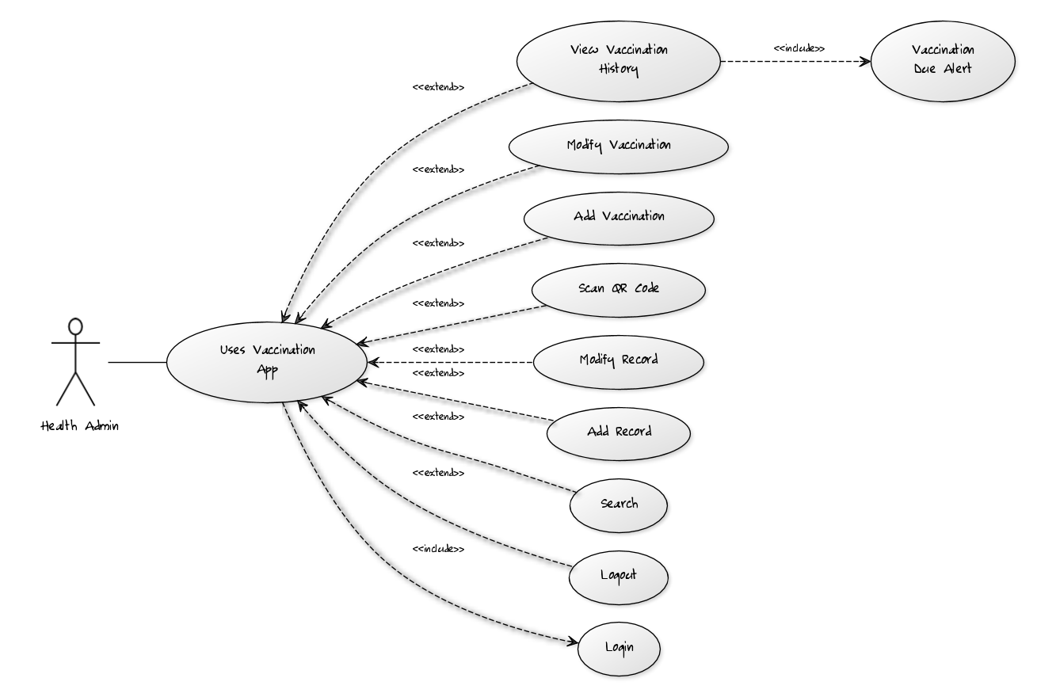

**3.3 Story board**

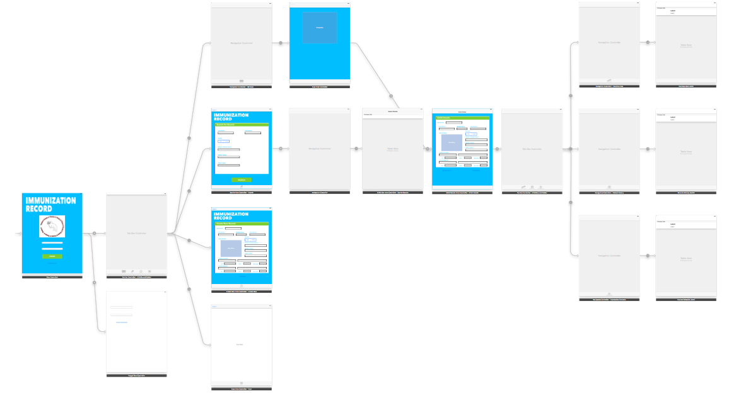

**3.3 Database**

